**Multi-objective RSM-based optimization of Diesel-Diethyl Ether blends in Diesel Engine to achieve Sustainable development goals**

Muhammad Kashif Jamil¹, Muhammad Usman*², Ahsan Hanif², Haider Nawaz², Yasser Fouad3, Muhammad Wajid Saleem4, Naseem Abbas5,*,⊥, Uzair Sajjad6, Khalid Hamid7,*

¹Mechanical Engineering Department RCET Campus University of Engineering and Technology Lahore Pakistan

²Mechanical Engineering Department Main Campus University of Engineering and Technology Lahore Pakistan

3Department of Applied Mechanical Engineering, College of Applied Engineering, Muzahimiyah Branch, King Saud University, P.O. Box 800, Riyadh, 11421, Saudi Arabia

4 Department of Mechanical and Energy Engineering, Faculty of Computing, Engineering and Media, School of Engineering and Sustainable Development, De Montfort University Dubai, UAE

5Department of Mechanical Engineering, Sejong University, Seoul 05006, Republic of Korea

6Department of Energy and Refrigerating Air-Conditioning Engineering, National Taipei University of Technology, Taipei 10608, Taiwan

7Department of Energy and Process Engineering, Norwegian University of Science and Technology, 7491 Trondheim, Norway

**⊥** Authors contributed equally to the first author.

* Corresponding Author: [naseem.abbas@sejong.ac.kr](mailto:naseem.abbas@sejong.ac.kr) (N.A), [muhammadusman@uet.edu.pk](mailto:muhammadusman@uet.edu.pk) (M.U), [khalid.hamid@ntnu.no](mailto:khalid.hamid@ntnu.no) (K.H)

**Abstract**

With the plummeting reserves of fossil fuels at present, there has been a growing imperative for sustainable energy technologies over the last couple of decades. This imperative highlight the need for a shift towards renewable sources, not just to fulfill the current energy demands but also to lessen environmental degradation, fostering an eco-conscious and sustainable future. One way to accomplish such a goal is the utilization of diesel-diethyl ether(D-DEE) blends, instead of neat diesel in compression ignition (CI) engines. This study presents the multi-objective RSM-based analysis and optimization of D-DEE blends (0,5 and 10 %. vol) at manifold engine speeds (1200, 1400, and 1600 rpm). The responses that were recorded in this research included brake power (B.P), brake thermal efficiency (BTE), brake-specific fuel consumption, and CO2 emissions. The results demonstrated an increment in brake power as well as brake thermal efficiency, along with the enhanced CO2 emissions whereas the BSFC decreased while using the Di-ethyl ether enrichment in a 4-stroke CI engine. Upon implementing optimization parameters, the results illustrated the optimal blend ratio of 9.5786 %. vol at 1600 rpm, along with the associated values of B.P, BTE, BSFC, and CO2 emissions which were, 1.26726 kW, 20.861%, 0.3354, and 7.837% vol., respectively for this optimized fuel. This study addresses the lack of research on optimizing engine conditions for diesel-DEE blends in CI engines, specifically focusing on diethyl ether as a renewable fuel. Using response surface methodology (RSM), it aims to bridge this gap and contribute to the understanding of optimal blend utilization. The current research also aligns with the attainment of an important sustainable development goal (SDG) which includes the availability of responsible consumption (SDG 12) and improved power generation, contributing towards a greener and cleaner future.

**Keywords:** Response Surface Methodology, Optimization, Di-ethyl ether, Sustainability, SDG, Renewable Alternative Fuels

1. **Introduction**

When compared with the 19th century, the human population has multiplied sixfold, and energy consumption has heightened up to 80 times in the 20th century [1]. The three most commonly known fossil fuels, i.e., coal, oil, and natural gas are responsible for approximately 80% of the global energy supply along with 65% of power generation [2]. According to a report issued by the International Energy Agency (IEA) in 2019, it was observed that the demand for the above-mentioned conventional fossil fuel has enhanced up to 1.4 million barrels/day (oil), 196 billion cubic meters (natural gas) and 1.4% (coal), respectively [3]. During a period of 7 years (2013-2020), the number of carbon emissions has also increased drastically [4]. As reported by BPSTATS in 2019, carbon emissions have a direct relationship with the rate of increase in energy consumption [5]. In consideration of the above-mentioned issues, the SDGs, defined by the United Nations (UN) in 2015, offer an essential global framework for confronting such pressing concerns and are considered a crucial tool for guiding efforts toward environmental sustainability and a greener and more stable future. Furthermore, as conventional fossil fuels continue to decline, the imperative for the implementation of sustainable development goals (SDGs) is greater than ever. Since the 1800’s, the applications of diesel engines include both light and heavy-duty vehicles [6]. These engines are acknowledged for being dependable, sturdy, and the most effective internal combustion engines. [7], [8]. Moreover, this particular type of engine has also been employed in power generation on a commercial scale for a long time. However, one of the major concerns aligned with diesel engines is, their release of toxic emissions into the atmosphere [9], [10]. Over the past 20 years, extensive research has been conducted in the field of alternative fuels to address the challenges associated with CI engines.

Alternative fuels including hydrogen and biofuels are considered to be efficient enough to provide effective solutions to these problems and can assist in the attainment of important SDGs while doing that [11], [12], [13], [14]. However, the complete transition towards modern technologies confronts different socio-technological barriers and necessitates a noteworthy investment. Thus, the bio-fueled internal combustion engines (ICE’s) are expected to remain significant. The use of biofuels in IC engines has been impeded for an extended period due to various factors, including the use of non-modified and unoptimized engines, as well as traditional methodologies for fuel blend preparation. Conventional methods, including accurate instrumentation and expensive experimentation for DEE generation, are not quite efficient concerning time. Such issues are aligned with SDG 12 (Responsible Production and Consumption) [15], [16], [17]. Subsequently, the development of alternate solutions is of paramount importance since it assists sustainable production and consumption practices [18], [19], [20], [21]. For achieving this SDG, computational analysis techniques can be used to investigate the relationship between the operating parameters and precisely optimize the several characteristics of compression ignition engines such as emissions, performance, and combustion. Among such techniques, response surface methodology has surfaced as an effective technique that allows the optimization of operating engine parameters by utilizing versatile input compositions and the employment of such technique for optimizing the DEE’s utilization in CI engines [22], [23], [24]. Such a methodology can assist in determining the accurate and bolstered model for optimizing the engine operations. By entertaining a wider range of output parameters, the current research promotes a more thorough understanding of the engine’s working parameters and hence provides further opportunities for reaching optimal engine conditions [25]. Among different alternative fuels, oxygenated fuels are of paramount importance, and among those oxygenates, diethyl ether (DEE) has proved itself quite worthy since it improves the cetane number of diesel and thus results in amplified performance [26].

A limited number of researches are currently available on DEE’s utilization as a supplement fuel for CI engines. Rakopols et al. analyzed the impact of DEE’s enrichment in single-cylinder 4-stroke diesel engines. They observed that the addition of DEE in diesel up to 24% reduction in smoke, CO, and NOx emissions and heightened HC emissions. Moreover, it was also highlighted as one of the major findings that the brake-specific fuel consumption (BSFC) depicted a slight increment but no increase in the brake thermal efficiency was observed [27], [28], [29]. Banapurmath et al. also investigated the potential of DEE as a renewable alternative to diesel by utilizing two different blends of diesel-diethyl ether i.e., 5% and 10 % for CI engine. The results illustrated an increment in brake thermal efficiency as well in NOx up to 20% whereas the CO, HC, and smoke were reduced substantially for a blend containing 5% diethyl ether. However, when evaluating the blend containing 10% diethyl ether, a reduction in brake thermal efficiency has been observed along with augmented brake-specific fuel consumption. [30]. Paul et al. also highlighted the influence of adding DEE with neat diesel in multiple proportions on a single-cylinder CI engine’s performance and emission characteristics. With the addition of 5% DEE, both brake thermal efficiency and NOx increased along with a prominent decline in brake-specific fuel consumption. However, with the enrichment of DEE up to 10%, both brake thermal efficiency and NOx reduced slightly and the brake-specific fuel consumption demonstrated an increase with this fuel blending. In the case of CO and smoke, both proportions of DEE showed a significant drop [31]. Karabektas et al. also inspected the effect of diesel-DEE utilization in dual-fuel engines containing up to 40% natural gas. The diethyl-ether was blended with neat diesel in two different proportions with diesel, i.e., 5% and 10%, and hence used as a pilot fuel [32]. The researchers concluded that the addition of DEE in both proportions had demonstrated an improvement in the engine’s brake thermal efficiency and brake-specific fuel consumption and lessened CO and NO emission in comparison to the standardized multi-fuel mode. Moreover, it was also manifested that the addition of DEE in diesel-biodiesel blends can significantly reduce CO, smoke, and brake-specific fuel consumption respectively [33]. Furthermore, Agarwal et al. also highlighted the importance of diethyl ether for CI engines by testing three different proportions of the mentioned oxygenated fuel i.e., 15%, 30%, and 45% on a three-cylinder tractor engine. This off-road tractor engine was tested at a constant speed of 1500 rpm with versatile loads, without any engine hardware modifications. The results of this study showed incremented brake thermal efficiency, lessened brake-specific fuel consumption, and comparable exhaust gas temperature along with reduced NOx emissions when compared with the neat diesel [34].

One of the major attributes of engines, i.e., performance is predominantly dictated by the in-cylinder combustion process, characterized as diffusion combustion, encompassing spray, atomization, diffusion, and combustion stage [35]. Latest developments in fuel injection systems, combustion technologies, and employment of alternative fuels present promising prospects to ameliorate fuel economy and mitigate emissions [36], [37]. Such innovative approaches when integrated with advanced combustion technologies, have significant potential to improve the engine’s efficiency and performance [38], [39]. By optimizing fuel delivery, refining combustion processes, and incorporating cleaner alternative fuels, substantial reductions in emissions and improved fuel efficiency can be attained. Continuous research and development in these domains will propel the adoption of these innovative technologies, contributing to a more sustainable future [21]. Table 1 highlights the prior studies performed on DEE to investigate its potential as a reliable and renewable alternative fuel for diesel engines. These studies have provided quite compelling evidence of DEE's usage in mitigating the harmful emissions from diesel engines, as well as enhancing their performance and reliability. Furthermore, a comprehensive literature review, presented in Table 1, highlights the favorable and significant application of DEE in contributing to the realization of SDG 12 and improved power generation.

**Table 1.** Prior studies on Diesel/DEE blends

|  |  |  |  |  |  |  |  |  |
| --- | --- | --- | --- | --- | --- | --- | --- | --- |
| Author Name and Reference | Fuel Blend | BP | BTE | BSFC | CO | CO2 | HC | NOx |
| Ibrahim et al. [40] | Diesel-DEE | _ | ↑ | ↓ | _ | _ | _ | _ |
| Mohanan et al. [41] | Diesel-DEE | _ | ↑ | ↓ | ↓ | _ | _ | _ |
| Iranmanesh et al. [42] | Diesel-DEE | _ | ↑ | _ | _ | ↑ | ↓ | ↓ |
| Devaraj et al. [43] | Diesel-Plastic Pyrolysis Oil- DEE | ↑ | ↑ | ↓ | ↓ | _ | ↓ | _ |
| Akshatha D.S et al. [44] | Biodiesel-DEE | _ | ↑ | _ | ↓ | ↑ | ↓ | _ |
| Saravanan et al. [45] | Diesel-DEE | _ | ↑ | ↓ | ↑ |  | ↑ | ↓ |
| Dr. V. Rambabu [46] | Mahua Methyl Ester (MME)-DEE | _ | ↑ | ↓ | _ | _ | _ | _ |
| Sezer [47] | Diesel-DEE | ↑ | ↑ | ↓ | ↑ | ↓ |  | ↑ |

Most of the research that has been discussed in the literature has utilized diethyl in two different concentrations i.e., 5% and 10%. It was found by the researchers that the fuel composition containing up to 10% diethyl ether has the best possible impact on the performance and emission characteristics of diesel engines. Several studies have attempted to incorporate diethyl ether at concentrations of up to 20% and 30%. Smigins et al. utilized diethyl ether-rapeseed oil blends to evaluate the performance and emission characteristics of a light diesel engine. This investigation resulted in a power reduction of up to 17% with almost a 15% increment in the brake-specific fuel consumption when utilizing diethyl ether up to 30%. However, the involvement of diethyl ether resulted in a significant reduction in the emissions. Both NOx and HC showed a substantial decline for all the diethyl ether blends along with a slight interaction in the CO2 [48]. Similarly, Mahla et al. evaluated diesel-diethyl ether-biogas blends containing diethyl ether in three different concentrations, i.e., 10, 15, and 20% respectively. This study showed that the best possible outcomes were determined when 10% diethyl ether had been utilized along with diesel and biogas[49]. While the high percentage of diethyl ether in such blends showed a positive impact on emission characteristics, their effect on the performance of the designated CI engines was less pronounced. Thus, this study also employed diethyl ether at such concentration where the best possible outcomes can be derived to enhance the utilization of diethyl ether Furthermore, via optimization, it has been briefly validated that employing diethyl ether in such concentrations, yields remarkable improvements in the performance, combustion and emission characteristics of diesel engines.

Response Surface Methodology, an advanced statistical and modeling technique, has been utilized in many researches to discern the most optimum operating conditions for both SI and CI engines. This technique helped the research to evaluate renewable alternative fuels, maximizing the performance while simultaneously mitigating the emissions of targeted automobiles. Thodda et al. utilized a water-cooled CI engine to investigate the effects of diesel-acetylene gas blends on the designated engine. The desirability approach was utilized to determine the optimum operating conditions to enhance the utilization of this particular fuel. Acetylene gas was introduced in three different flowrates i.e., 2, 4, and 6 LPM. Other parameters including injection timing, injection pressure, and compression ratio were also optimized using RSM. The optimal conditions in this study were 6 LPM gasoline with higher IP of 240 bar, CR of 18, and IT of 23ºCA bTDC. The desirability factor for this model was evaluated to be 0.649 which further scrutinizes the practical feasibility of the mentioned idea[22]. Simsek et al. employed RSM to showcase the impact of LPG integration with gasoline on spark ignition engines’ performance and emission characteristics. With the help of RSM, the optimum concentration of LPG for the prime performance and emission reduction was found to be 35% among all the utilized blends (0, 25, 50, 75, and 100% LPG) [50]. Malik et al. deployed this unique and modern technique to highlight the importance of methanol insertion in SI engines. Performance, emission, and lubricant oil degradation were evaluated as the response variables in this study. Three different concentrations of methanol i.e., 6, 12, and 18% were utilized with gasoline at manifold engine speeds and versatile loading conditions. The mentioned study ensured the remarkable impacts of the utilization of methanol along with gasoline for SI engines. After the impact analysis, optimization has been performed via RSM to assess the best input parameters to assure the prime responses, accordingly. The optimum conditions for methanol utilization were found to be 8% methanol concentration at 3400 rpm and higher loading conditions. The results were later further validated by a desirability factor of 0.73 [51]. Usman et al. also yielded significant achievements when using diesel-hydroxy gas blends in a 4-stroke air-cooled diesel engine. Hydroxy gas flow rate and engine load were appointed as the input parameters for the mentioned study. It was observed that hydroxy gas-enriched diesel brought significant enhancement in performance along with a substantial reduction in exhaust emissions. Furthermore, the RSM-based optimum conditions for this research were found to be 8 L/min of HHO at 41% engine load. The desirability factor for this approach was determined to be 0.733 which seems feasible when it comes to the practical implantation of this idea on the commercial scale [52]. Thus, from the above-mentioned studies, it can be deduced that RSM has been heavily employed in the past and recent research to investigate the intricate realm of renewable alternative fuels for the transportation sector. Due to such enhanced utilization and fruitful outcomes of RSM, this technique has also been employed in the current study to analyze the impact of diesel-diethyl ether on CI engines.

The ideas and strategies expressed in before mentioned studies have provided an impactful analysis of diesel-diethyl ether blends which has led the automotive sector to shift towards the utilization of renewable alternative fuels. With the employment of diethyl ether as a renewable additive for CI engines, performance can be enhanced, and emissions can be mitigated significantly along with the improved combustion and fuel economy. The strategies implemented in this research have provided us with profound insights on the utilization of renewable alternatives such as diethyl ether as well as paved the way for the upcoming research endeavors. The aforementioned research has also highlighted the challenges to utilizing such renewable fuels in the automotive sector. The research of such kind not only allows researchers and engineers to design more efficient and less environmentally impactful automobiles but also provides necessary assistance for developing a sustainable environment for the upcoming generations.

It has been witnessed in prior research that most of them have relied on traditional two-dimensional graphical analysis to assess the compatibility of diesel-diethyl ether blends in CI engines. These 2D graphs utilize the idea of investigating the impact of only a single input parameter which is the percentage of diethyl ether in the conventional diesel, by keeping other parameters constant. The mentioned research currently lacks consideration for other crucial factors such as the combined impact of several engine parameters including engine speed, load, and fuel injection parameters. This research has also lacked comprehensive statistical analysis to assess the goodness of fit and equation development for the recorded data. Moreover, in the previous research, concerned with the employment of diethyl ether in CI engines, no concept of optimization had been employed to enhance the utilization of diethyl ether as a renewable additive for compression ignition engines.

Analyzing the complexities of processes within the diesel engine cylinder poses significant challenges for accurate assessments using conventional methods. Furthermore, modifying the research engine for experimentation can incur significant costs and time. The identified current research gaps and associated challenges necessitate deep investigation on the impacts of diethyl ether as a renewable alternative fuel and hence this study endeavors to fulfill such knowledge and experimental gaps by conducting an in-depth statistical analysis including the validation of previous studies along with the utilization of RSM based optimization to evaluate the critical input parameters such as manifold fuel compositions and other engine operating conditions. The scope of this study encompasses the combined impact of such crucial parameters on the designated performance, emissions, and combustion characteristics of CI engines. Moreover, the impact of such modifications on the engine’s reliability and stability has also been evaluated in detail in the scope of this study.

Thus, the primary objective of this research is to harness the power of response surface methodology (RSM) to discern the optimal engine conditions and identify the most favorable fuel blend for identifying the usability of renewable fuels such as diethyl ether in the transportation sector. This not unique but assertive aspect of the current study will enable the researchers to delve further into the realm of alternative fuels and allow them to polish their skills in the domain of intricate mathematical modeling and advanced statistical analysis. The employment of such modern techniques to assess and showcase the importance of renewable alternative fuels for the automotive sector along with the effort to provide a detailed analysis of optimized and stable operating conditions can be defined as the novelty of this research.

The ultimate motivation for this research stems from the pressing need to address the performance as well as environment-related challenges faced by diesel engines. By conducting RSM-based analysis and optimization to investigate the impact of diesel-diethyl ether blends, the major aim is to optimize the engine's performance while simultaneously lessening the emissions. This study contributes to the real world by providing a sustainable solution to boost the efficiency and environmental footprint of CI engines, thereby promoting improved air quality and minimizing climate change. Furthermore, studies of this kind will pave a suitable way for the adoption of renewable alternative fuels in the automotive industry, aligning with global sustainability goals and fostering a greener future for generations to come. Additionally, with the depletion of diesel fuel reserves becoming a growing concern, this study provides a promising avenue for mitigating reliance on finite resources by exploring the potential of diethyl ether, which offers superior combustion properties and enhanced compatibility with diesel. The contribution of this research will allow us to achieve an important SDG (Responsible Production and Consumption) and promoting a more sustainable and buoyant future for the upcoming generations as a whole makes it distinctive. This study presents itself as a noteworthy endeavor to strive for responsible consumption and production and improved power generation.

1. **Materials and Methods**

The particular section highlights the details of the preparation of fuel blends, requirements for engine test beds, and fundamental details of RSM-based optimization.

* 1. ***Preparation of fuel blends***

For this study, diethyl ether (DEE) was procured from Shahmurad Chemicals, one of the renowned DEE producers in Pakistan and diesel was obtained from TOTAL PARCO, Pakistan. Diesel, as a major ingredient in fuel blends, was embarked on as the reference for all fuel compositions. Table 2 showcases the physio-chemical properties of both diesel (D100) and DEE. Furthermore, several standard procedures are being used for determining the physio-chemical properties of the employed fuels. Two different fuel blends were prepared with the addition of di-ethyl ether in diesel, i.e., D95-DEE5 (95% diesel and 5% DEE by volume) and D90-DEE10 (90% diesel and 10% DEE by volume). A magnetic stirrer was also employed to generate a homogeneous mix of these fuel blends.

**Table 2.** Physio-chemical properties of Diesel and DEE [53], [54], [55], [56], [57], [58]

|  |  |  |  |  |  |
| --- | --- | --- | --- | --- | --- |
| Fuel property | Diesel | Standards | DEE | D95-DEE5 | D90-DEE10 |
| Chemical formula | C12H23 | _ | (C2H5)2O | _ | _ |
| Density, kg/m3 | 849 | ASTM D975-21 | 713 | 842.2 | 835.4 |
| Gross calorific value, MJ/kg | 45.5 | ASTM D4809-00 | 36.873 | 45.068 | 44.637 |
| Auto-ignition temperature, °C | 210-350 | ASTM D6890-06 | 150-160 | 207-340 | 204-330 |
| Cetane number | 50 | ASTM D613 | 125 | 54 | 58 |
| Viscosity, mm2 /s | 3.25 | ASTM D445 | 0.23 | 3.1 | 2.95 |
| Boiling point, °C | 180-360 | ASTM D86 | 35 | 170-345 | 165-330 |
| Oxygen content, % by mass | 0 | ASTM UOP73-09 | 21.6 | 1.08 | 2.16 |
| Flash Point, °C | 55 | ASTM D93 | -40 | 51 | 46 |

* 1. ***Engine Test Bed and Testing Plan***

A single-cylinder, air-cooled Lombardino 15 LD 315 CI Engine with a hydraulic-brake engine testbed was utilized. Table 3 highlights the specifications of the test engine. A dynamometer, connected to the engine’s shaft was also employed for speed measurements. The emissions were recorded with the help EMS-5002 analyzer whose probe was inserted in the exhaust of the test engine. To measure the fuel flow rate, a 500-ml measuring cylinder (0.5 ml grade) was employed. An interconnected piping system was used for applying load, and water inside it as a working fluid. The detailed experimental setup is shown in Figure 1. The accomplishment of a data acquisition system involves the utilization of a system, equipped with a conditioning circuit for converting sensor signals into digital ones. A software, termed, DYNO-MAX was used to measure the engine’s performance whereas the emission measurement system encompassed a broad range of engine speeds for profound data collection in versatile operating conditions. No structural modifications were made for the engine testing. The performance and emissions were recorded at three different speeds, 1200, 1400, and 1600 rpm. The set load was kept intermediate during the process of data accumulation. Three repetitions of each measurement were performed to reduce human error. For tunning of the engine at a steady state, neat diesel has been used as a starting fuel. To maintain consistency and avoid the accumulation of water molecules, the test fuel mixtures were prepared just before the testing. Dynomite 2010 precisely measured the speed values and the output parameters, including BP, whereas BTE, and BSFC were calculated using density and heat values. The summary of the testing scheme is shown in Table 4.

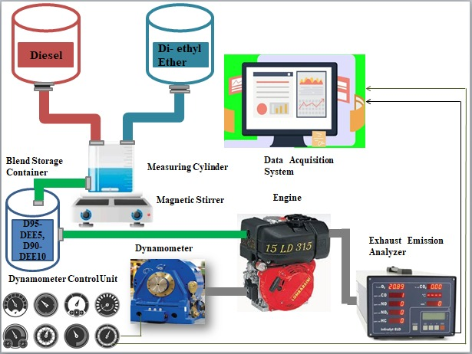

**Figure 1.** Experimental Setup

**Table 3.** Engine Specifications

|  |  |
| --- | --- |
| Description | Specifications |
| Bore | 7.8 cm |
| Stroke | 6 cm |
| Compression ratio | 20.3 |
| (Maximum torque)2400rpm | 15 N-m |
| Recommended battery | 12/44 (V/Ah) |
| Lubricant Oil Sump capacity | 1.2 L |
| Retrofitted Dynamometer type | Hydraulic |
| Injection type | Direct |
| Engine weight | 33kg |

**Table 4.** Comprehensive Testing Scheme

|  |  |
| --- | --- |
| Factors | Description |
| Speed range | 1200 to 1600 rpm with an interval of 200 rpm |
| Fuels | Diesel (D), Diesel-DEE blends (D-DEE) |
| Performance parameters | Brake power, Brake Thermal Efficiency, and Brake specific fuel consumption |
| Emission parameters | CO2 |
| Ambient temperature | 24 ℃ |
| Atmospheric pressure | 101.325 kPa |
| RSM based analysis | Used Design Expert 13 to perform Response Surface Methodology (RSM) |
| RSM based optimization | Performed RSM-based optimization to determine the optimum conditions for engine working |

* 1. ***Response Surface Methodology***

Response Surface Methodology (RSM) can be defined as a statistical and mathematical technique that can be used in line with numerical experimentation for modeling as well as simulating experimental responses. It employs the defined experimentation for developing and optimizing the models for output parameters. In RSM models, quadratic polynomial models are used to evaluate the combined impact of input parameters on the recorded output parameters [38]. RSM allows for the simultaneous evaluation of multiple factors and their interactions with relatively few experiments, saving time and resources. Moreover, RSM generates mathematical models that describe the relationship between input variables and output responses, facilitating the interpretation of experimental results. RSM can handle experimental noise and variability, providing reliable estimation of response surfaces even in the presence of error [59]. Additionally, it provides a systematic approach to optimizing processes or products by identifying the optimal combination of input variables to achieve desired output responses. However, there are some limitations associated with this constructive technique. RSM assumes a linear relationship between input variables and output responses, which may not always hold for complex systems with nonlinear behavior [60]. Additionally, RSM models are valid only within the experimental region defined by the design of experiments, limiting extrapolation to regions beyond the experimental range [61], [62]. RSM requires statistical expertise for model fitting, interpretation, and optimization, which may pose challenges for less experienced researchers. Also, the choice of experimental design and model selection can significantly impact the results and conclusions drawn from RSM analyses. In conclusion, Response Surface Methodology (RSM) serves as a powerful tool for optimizing processes and products, offering efficiency, interpretability, and robustness [63]. Despite its limitations, RSM remains critical for optimization purposes, enabling researchers to systematically explore the relationship between input variables and output responses to achieve optimal outcomes. Its ability to efficiently optimize processes while providing interpretable models underscores its importance in various fields of research and industry.

A definite model, termed Central Composite Design (CCD) has been employed for evaluating the relationship between set input parameters and collection of variable responses and the creation of the Design of Experiment (DOE). The independent input parameters, including the engine speed and DEE concentration, have been employed for creating optimized models of BP, BSFC, BTE, and CO2 at three levels (-1,0,1) as expressed in Table 5. To assess the pure error in recorded values, a DOE consisting of 13 experimental runs was created for which the details have been catered in Table 6.

Table 5. Central Composite Model

|  |  |  |  |
| --- | --- | --- | --- |
| Parameters | Values | | |
| -1 | 0 | 1 |
| Engine Speed | 1200 | 1400 | 1600 |
| HHO-Concentration | 0 | 5 | 10 |

Table 6. Experimental Runs

|  |  |  |  |  |  |  |
| --- | --- | --- | --- | --- | --- | --- |
| Sr. No | Concentration (%. vol) | Speed (rpm) | B.P (kW) | Efficiency (%) | BSFC (kg/kWh) | CO2 (%) |
| 1 | 5 | 1600 | 1.294 | 21.87 | 0.344 | 7.7 |
| 2 | 5 | 1400 | 1.107 | 20.59 | 0.368 | 7.25 |
| 3 | 10 | 1600 | 1.264 | 20.58 | 0.336 | 7.8 |
| 4 | 5 | 1400 | 1.114 | 20.69 | 0.344 | 7.43 |
| 5 | 5 | 1400 | 1.121 | 20.79 | 0.344 | 7.49 |
| 6 | 5 | 1200 | 0.955 | 19.42 | 0.418 | 6.8 |
| 7 | 0 | 1400 | 1.012 | 18.29 | 0.433 | 7 |
| 8 | 10 | 1200 | 0.916 | 18.56 | 0.428 | 6.9 |
| 9 | 0 | 1200 | 0.875 | 17.03 | 0.465 | 6.6 |
| 10 | 0 | 1600 | 1.264 | 20.58 | 0.414 | 7.3 |
| 11 | 5 | 1400 | 1.138 | 21.01 | 0.344 | 7.57 |
| 12 | 5 | 1400 | 1.128 | 20.89 | 0.344 | 7.51 |
| 13 | 10 | 1400 | 1.062 | 19.87 | 0.371 | 7.6 |

1. Results and Discussions

*3.1 Brake Power (BP)*

For brake power, Table 7 illustrates the ANOVA results and fit statistics. The F-value of BP is found to be 128.17 and the lack of fit calculated for the entire model is 3.84 which is declared as ‘not significant’ for the recorded values. The p-value for the entire model is less than 0.05 which shows that the quadratic model for BP is significant and thus follows the boundaries of a 95% confidence interval (CI). Furthermore, the adjusted R2 (0.9815) and predicted R2 (0.9319), have a difference of less than 0.2 and thus highlight the significance of the shown model. Table 7 also depicts that the two independent input parameters, i.e., engine speed and DEE concentration are also significant. The 2FI model and cubic model are classified as aliased due to their poor fitness and among all models available, the quadratic model was best fitted due to its bolstering fit summary. For the generated model of BP, Eq (1). represents the regression equation (coded),

……………………...(1)

**Table 7.** Statistical Summary of ANOVA results for BP

|  |  |  |  |  |  |  |
| --- | --- | --- | --- | --- | --- | --- |
| Source | Sum of Squares | df | Mean Square | F-value | p-value |  |
| Model | 0.2066 | 5 | 0.0413 | 128.17 | < 0.0001 | significant |
| A-DEE Concentration | 0.0014 | 1 | 0.0014 | 4.28 | 0.0773 |  |
| B-Engine Speed | 0.193 | 1 | 0.193 | 598.58 | < 0.0001 |  |
| Concentration* Speed | 0.0004 | 1 | 0.0004 | 1.3 | 0.2911 |  |
| Concentration2 | 0.0118 | 1 | 0.0118 | 36.6 | 0.0005 |  |
| Engine Speed² | 0.0014 | 1 | 0.0014 | 4.2 | 0.0796 |  |
| Lack of Fit | 0.0017 | 3 | 0.0006 | 3.84 | 0.1131 | not significant |

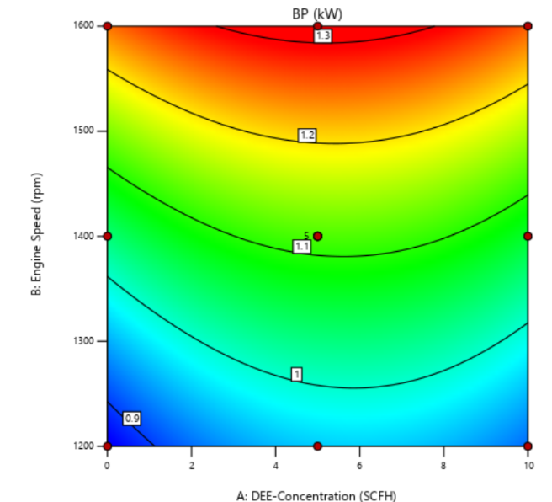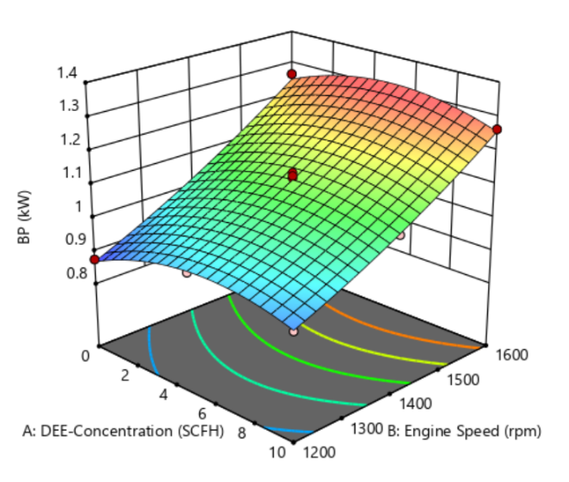

1. (b)

Figure 2. (a) Contour plot (b) 3D response surface plot

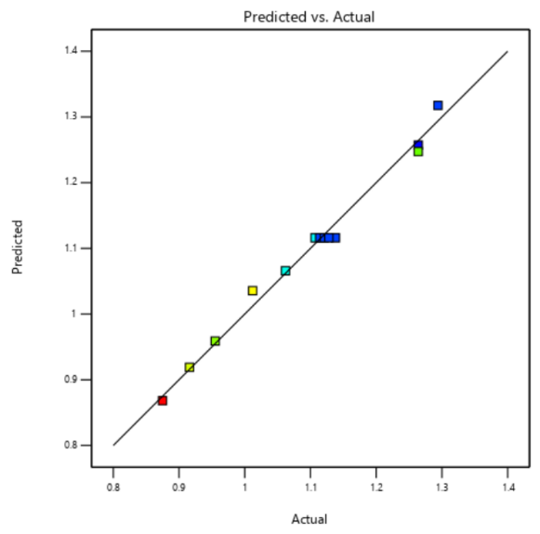

Figure 3. Actual BP vs Predicted BP

Figure 2. (a) demonstrates the impact of DEE addition in diesel for designated CI engines at versatile speed values. The red region in the contour plot depicts the maximum brake power against engine speed and DEE concentration. It can be observed that as the DEE concentration increases with the increment in speed, the BP of the assigned engine gets amplified. Moreover, similar results can be seen in Figure 2. (b) in a more explicit manner. The increase in the brake power due to DEE addition in neat diesel is owing to its rich oxygen content. The presence of oxygen molecules significantly enhances the oxygen content of the diesel-DEE fuel blends and thus results in improved and complete combustion [64]. Furthermore, the heightened volatility of DEE as compared to diesel improved the fuel-air mixing before combustion and this further enhanced the combustion efficiency. Also, DEE possesses quite a better cetane number when it comes in comparison with the neat diesel [65], [66]. This property of DEE also makes the fuel ignite quite easily due to compression. This shorter delay time results in more complete fuel combustion and hence a heightened brake power can be obtained, consequently [67]. Several graphs and diagnostic tests can also be performed to validate the accuracy of the given model. In general, for effective models, a slight difference between experimental and predicted values is desirable. Figure 3 clearly explains the difference between actual and predicted values for the BP model which is also an assurance of a good fit for the quadratic regression model. The adequate precision (36.8467) for the analyzed model of BP is quite convincing since its value is much greater than the required value, representing the goodness of fit for the measured data.

***3.2 Brake Thermal Efficiency (BTE)***

The ANOVA results for brake thermal efficiency are depicted in Table 8. It can be observed that the F-value for the BTE model is 71.91 as well as a p-value of less than 0.05. Both these values ensure the goodness of fit of the recorded data. Furthermore, the F and p-values in line with the lack of fit of 3.74 (not significant) for this current model, indicate that the model for BTE is significant and fulfills the requirements for validating the 95% CI. The values of both predicted (0.8564) and adjusted (0.9673) R2 seem in agreement since they possess a difference, of less than 0.2. Because of the poor fitness and aliased nature of cubic and 2FI models as well as for its best fitness summary, the quadratic model was chosen for BTE. Once the ANOVA is performed for the BTE model, the regression equation (coded) is represented by Eq. (2).

……………………...(2)

**Table 8.** Statistical Summary of ANOVA results for BTE

|  |  |  |  |  |  |  |
| --- | --- | --- | --- | --- | --- | --- |
| Source | Sum of Squares | df | Mean Square | F-value | p-value |  |
| Model | 21.19 | 5 | 4.24 | 71.91 | < 0.0001 | significant |
| A-DEE-Concentration | 1.61 | 1 | 1.61 | 27.35 | 0.0012 |  |
| B-Engine Speed | 10.72 | 1 | 10.72 | 181.91 | < 0.0001 |  |
| Concentration*Speed | 0.5852 | 1 | 0.5852 | 9.93 | 0.0161 |  |
| Concentration2 | 6.98 | 1 | 6.98 | 118.51 | < 0.0001 |  |
| Engine Speed² | 0.0018 | 1 | 0.0018 | 0.0297 | 0.8681 |  |
| Lack of Fit | 0.3042 | 3 | 0.1014 | 3.74 | 0.1173 | not significant |

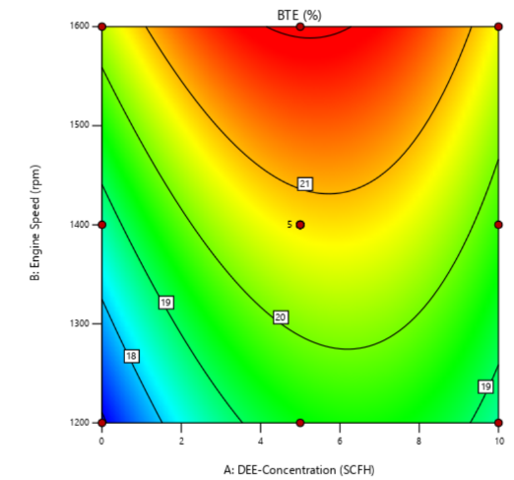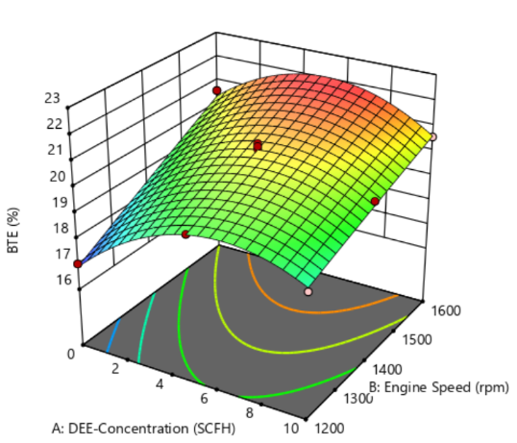

1. (b)

**Figure 4.** (a) Contour plot (b) 3D response surface plot

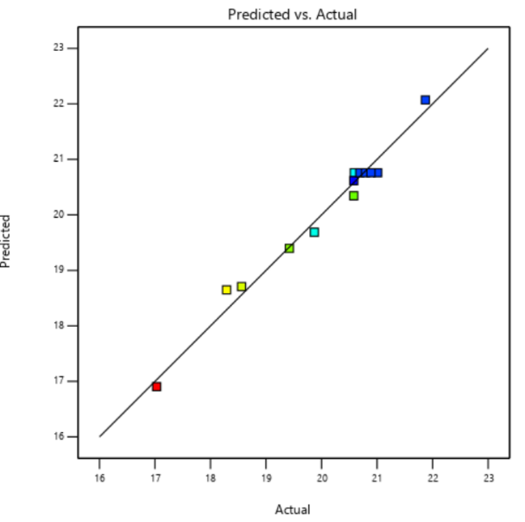

Figure 5. Actual BTE vs Predicted BTE

Figure 4 represents the contour plot as well as the 3D surface plot for the BTE model. These models allow us to have a complete analysis of the effect of engine speed and DEE concentration on the BTE of the ordained CI engine. The intensity of the contour plot in Figure 4. (a) changes from blue color to red color indicating the conditions for lowest and maximum of BTE. The presented contour plot depicts that the BTE of the diesel engine increases as the speed and the DEE concentration get incremented. The 3D surface model in Figure 4. (b) also highlights the variations in BTE concerning engine speed and DEE concentration. The 3D plot shows that the efficiency in the beginning is slightly less. The reason for such a low value of BTE is the obstacles the engine has to confront while overcoming the inertia and bringing the engine into a s

running state. The higher diffusivity heightened oxygen content, and a lesser difference in the density of DEE as compared to neat diesel are the reasons why the BTE constantly increases [68]. The major reason for this heightened BTE is the slight difference in the density of the two fuels. This resulted in the homogeneity of the fuel mixture and the enhanced volatility of DEE played its role in the improved air-fuel mixing [69]. The addition of DEE in diesel also improved the cetane number of diesel-DEE blends and thus all the previously mentioned reasons led to a single output, i.e., complete fuel combustion which directly led to the enhanced BTE [70]. Furthermore, the higher latent heat of vaporization associated with DEE as compared to neat diesel yields more brake power which ultimately enhances the brake thermal efficiency of the CI engine [71]. Multiple diagnostic tests can be done to check the accuracy of the developed BTE model. The BTE model shows good fitness due to the lesser difference it possesses between its actual and predicted values as shown in Figure 5. It can be observed that the recorded values are slightly deviated from the 45-degree ideal regression line. The adequate precision for the current model is 31.31 and since it is quite greater than the required value, it also tells us about the goodness of fit of the recorded parameters.

***3.3 Brake-Specific Fuel Consumption (BSFC)***

ANOVA results for the third response variable, i.e., brake-specific fuel consumption are illustrated in Table 9. The model developed for BSFC seems quite significant owing to its F-value of 37.47 and a p-value less than 0.05. Also, the lack of fit, calculated for this model is 1.12 which is ‘not significant’ and thus ensures the goodness of fit of the documented data. The p-values for both the engine speed as well as DEE concentration are less than 0.05 which not only validates the significance of the model but also validates the recorded data within the defined 95% CI. The difference between the adjusted (0.9382) and predicted (0.8579) R2 values is less than 0.2 which makes them in quite reasonable agreement. The model chosen for BSFC is a quadratic one since it represents the best-fit summary when compared with the aliased cubic and 2FI models. Eq. (3) presents the RSM-evaluated regression equation (coded) for the BSFC model,

……………………...(3)

**Table 9.** Statistical Summary of ANOVA results for BSFC

|  |  |  |  |  |  |  |
| --- | --- | --- | --- | --- | --- | --- |
| Source | Sum of Squares | df | Mean Square | F-value | p-value |  |
| Model | 0.0227 | 5 | 0.0045 | 37.47 | < 0.0001 | significant |
| A-DEE-Concentration | 0.0052 | 1 | 0.0052 | 43.06 | 0.0003 |  |
| B-Engine Speed | 0.0078 | 1 | 0.0078 | 64.72 | < 0.0001 |  |
| Concentration*Speed | 0.0004 | 1 | 0.0004 | 3.47 | 0.105 |  |
| Concentration2 | 0.0048 | 1 | 0.0048 | 39.94 | 0.0004 |  |
| Engine Speed² | 0.0012 | 1 | 0.0012 | 9.93 | 0.0161 |  |
| Lack of Fit | 0.0004 | 3 | 0.0001 | 1.12 | 0.4392 | not significant |

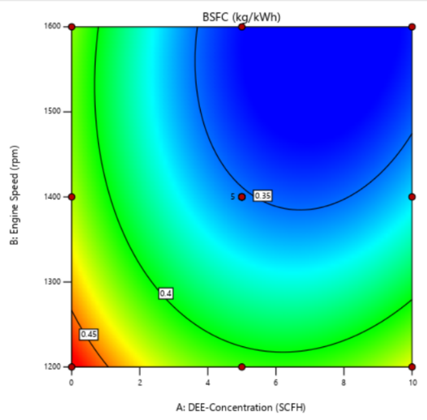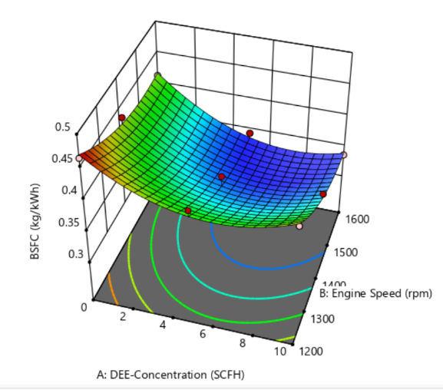

1. (b)

**Figure 6.** (a) Contour plot (b) 3D response surface plot

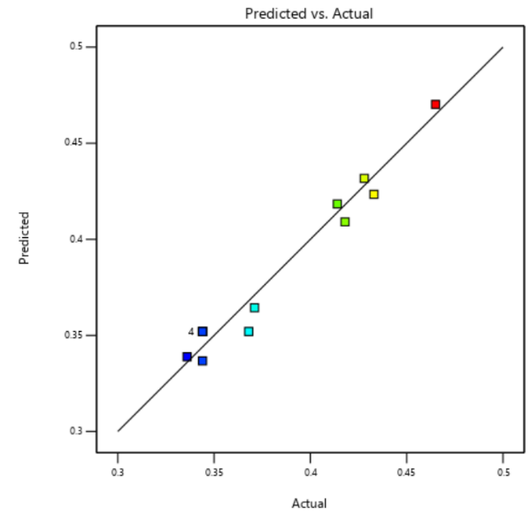

Figure 7. Actual BSFC and predicted BSFC

Figure 6 showcases the impact of two independent input parameters on the BSFC of the tested CI engine with the help of contour and 3D surface plots. In Figure 6. (a), the given contour plot depicts a range of BSFC with blue being the lowest and red being the highest values. The shift of the plot clearly illustrates the trend of BSFC throughout testing which can be defined as that when the engine speed and DEE concentrations increase, the BSFC shows a decline in its value as compared to the neat diesel. In the beginning, the BSFC values are quite high because of the unstable engine running as well as the unaddressed flywheel’s inertial forces. As the engine becomes stable and the percentage of DEE in diesel starts increasing, the BSFC starts to drop. This behavior of diesel-DEE fuel blends can be attributed to the enhanced oxygen content, heightened cetane number, and higher latent heat of vaporization of DEE in comparison to neat diesel [34], [19]. The low-density difference between the two fuels also makes the fuel blend quite homogeneous and the increased cetane number reduces the time delays during the ignition of the fuel [72]. These characteristics of DEE make the fuel more combustible and hence a complete and improved combustion can be achieved consequently [73]. This directly leads to lesser fuel consumption when compared with the employment of simple diesel in CI engines. Figure 7 explains a comparison between actual and predicted values of BSFC. From the perspective of it, a slight deviation can be viewed from the ideally drawn 45-degree regression line. The slight deviation from the ideal line can be neglected since it doesn’t affect the overall model. Furthermore, the adequate precision for the mentioned model is 17.83 which also highlights the goodness as well as accuracy of the recorded data.

***3.4 CO2 Emissions***

Similarly, the ANOVA results of CO2 emissions are displayed in Table 10. Since both engine speed as well DEE concentration follow the 95% interval by having p-values less than 0.05, it demonstrates that the model is significant and is practically feasible at the same time. The accuracy of the data can be validated via an agreeable difference between the adjusted (0.9192) and predicted R2 (0.8381). The F-value for the CO2 model is 28.29 whereas the lack of fit is also, ‘not significant’ as expressed by a value of 0.4087. These values highlight the goodness of fit of the recorded data. Furthermore, the best-chosen model for CO2 is the quadratic one since the other models, including cubic and 2FI, showed poor fitness as well are also aliased in nature. For the CO2 model, the generated quadratic equation (coded) is expressed in Eq. (4).

……………………...(4)

**Table 10.** Statistical Summary of ANOVA Results for CO2

|  |  |  |  |  |  |  |
| --- | --- | --- | --- | --- | --- | --- |
| Source | Sum of Squares | df | Mean Square | F-value | p-value |  |
| Model | 1.58 | 5 | 0.3168 | 28.29 | 0.0002 | significant |
| A-DEE-Concentration | 0.3267 | 1 | 0.3267 | 29.17 | 0.001 |  |
| B-Engine speed | 1.04 | 1 | 1.04 | 93.02 | < 0.0001 |  |
| Concentration*Speed | 0.01 | 1 | 0.01 | 0.893 | 0.3761 |  |
| Concentration2 | 0.0438 | 1 | 0.0438 | 3.91 | 0.0886 |  |
| Engine Speed² | 0.0854 | 1 | 0.0854 | 7.63 | 0.028 |  |
| Lack of Fit | 0.0184 | 3 | 0.0061 | 0.4087 | 0.7559 | not significant |

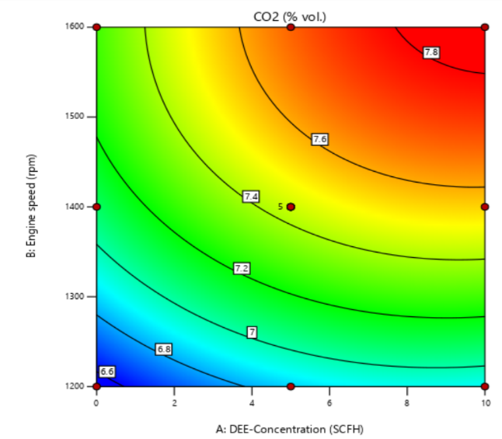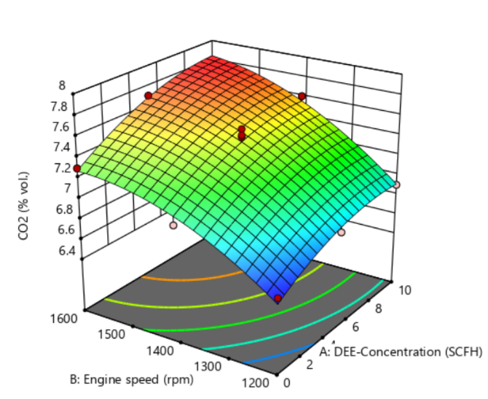

1. (b)

**Figure 8.** (a) Contour plot (b) 3D response surface plot



Figure 9. Actual CO2 emissions and predicted CO2 emissions

From Figure 8. (a) and (b), the combined effect of engine speed as well as the DEE concentration can be analyzed. The contour plot shown in 8 (a) depicts the varying intensity of CO2 emission concerning both input parameters. The color range is from blue to red with blue being the lowest value and red being the highest value of CO2. The 3D surface plot also displays a similar result but in a more explained and detailed manner. From both contour and 3D surface plots, it can be concluded that CO2 emissions continuously increase with the increase in engine speed and DEE -concentration. The major reason behind this behavior includes the presence of oxygen molecules in DEE which has been blended with neat diesel for testing purposes [74], [75]. The rich oxygen content of DEE enables the complete fuel combustion of the diesel-DEE blend. As the percentage of DEE changes from 5% to 10%, the oxygen content in the fuel gets further heightened, thus resulting in more CO2 emissions and lessened CO which may have occurred due to the partial combustion of the fuel [76]. Figure 9 illustrates the results of several accuracy tests that can be performed to analyze the data statistically. The data is plotted in Figure 9 has negligible deviations from the predicted or ideal regression line. The adequate precision of the data is calculated as 18.0824, which also ensures a good fit summary of the submitted data.

1. **RSM based Optimization**

Optimization’s fundamental aim is to shift the output to the maximum value. The computational analysis technique, termed RSM, employs a definite set of steps to achieve this goal of optimization by both maximizing and minimizing the output parameters of the study. The optimization study has been done by employing the RSM in a renowned statistical software, Design Expert. The same level of importance (3 out of 5) has been given to all the response variables for identifying their optimal states. For BP, BTE, and CO2 the goal of maximum was assigned whereas the reverse i.e., the goal of minimum has been allotted to the BSFC. All the above-mentioned details are showcased in tabular form in Table 11.

**Table 11.** Optimization goals and importance

|  |  |  |  |  |  |  |
| --- | --- | --- | --- | --- | --- | --- |
| Name | Goal | Lower Limit | Upper Limit | Lower Weight | Upper Weight | Importance |
| A: DEE-Concentration | is in range | 0 | 10 | 1 | 1 | 3 |
| B: Speed | is in range | 1200 | 1600 | 1 | 1 | 3 |
| BP | maximize | 0.875 | 1.294 | 1 | 1 | 3 |
| BTE | maximize | 17.03 | 21.87 | 1 | 1 | 3 |
| BSFC | minimize | 0.336 | 0.465 | 1 | 1 | 3 |
| CO2 | maximize | 6.6 | 7.8 | 1 | 1 | 3 |

After the optimization analysis, the deduced optimal conditions for the engine’s operations include an engine speed of 1600 rpm and DEE-concentration of 9.5786 %. vol. These optimal values are highlighted in the slope table by red dots, shown in Figure 10. As far as the response variables are concerned, the values for BP, BTE, BSFC, and CO2 emissions at the above-mentioned optimum conditions of input parameters are, 1.26726 kW, 20.861%, 0.3354, and 7.837% vol. respectively. The optimized equations for all the output parameters are presented in Eq. 5, 6, 7, and 8, respectively. All the results that are mentioned above highlight the demanding potential of DEE in CI engines. But there comes the limitation of utilizing all the fuel compositions for practical purposes as it will not only destabilize the usage of DEE for CI engines but also go against the SDG achievement as described in previous sections. To overcome such limitations and to refrain from the obstacles in DEE’s usage as a renewable alternative fuel, the optimum conditions for the fuel blend and engine speed have been determined. Furthermore, the desirability factor can also be utilized as a parameter for assessing the practical feasibility of the entire optimized model. Its value initiates from 0 and ends at 1 as an ideal condition. For the mentioned model, the desirability factor is 0.928 near the ideal condition as highlighted in Figure 11. Such value of the desirability factor ensures that the model is practically feasible and can be utilized with ease first at a small scale and then towards commercial utilization of DEE as an acceptable and green alternative fuel for CI engines.

…………………....................................................................................…... (5)

……………………... (6)

……………………........................... (7)

……………………..................................................................................... (8)

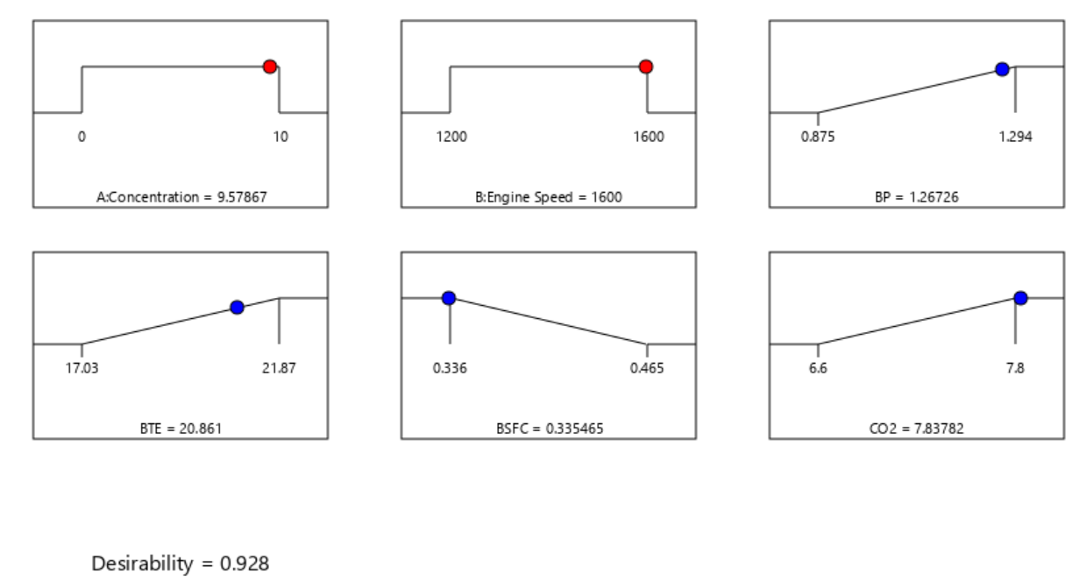

**Figure 10.** Optimized inputs and response variables

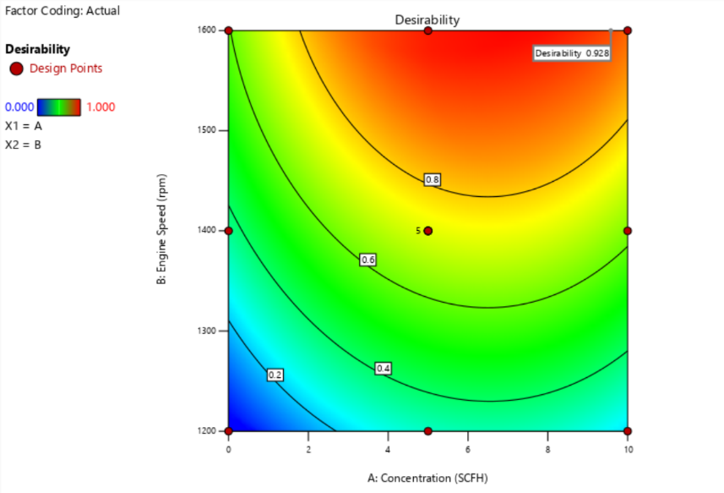

**Figure 11.** Desirability Contour

1. **RSM-based optimization validation:**

To further check the validity of the response variables of the optimized model for diesel-DEE blends, practical experimentation was also been performed for the optimal values of input parameters, i.e., DEE concentration and engine speed. The Absolute Percentage Errors (APEs) have also been evaluated for the RSM generated and experimental values as expressed in Table 12.

**Table 12.** RSM Validation

|  |  |  |  |  |  |  |
| --- | --- | --- | --- | --- | --- | --- |
| **DEE-Concentration (%. vol)** | **Engine Speed (rpm)** | **Value** | **BP (kW)** | **BTE (%)** | **BSFC (kg/kWh)** | **CO2 (%)** |
| 9.5786 | 1600 | RSM optimized | 1.2672 | 20.86 | 0.3354 | 7.83 |
| Experimental | 1.3204 | 21.53 | 0.3423 | 7.95 |
| APE | 4.2 | 3.25 | 2.06 | 1.6 |

After detailed experimentation and evaluation of APEs, it can be concluded that the RSM-generated values are near the experimental values as the APEs for all output parameters are less than 5%. Since the APEs for all the response variables are less than 5%, it can be deduced that these values are valid and precise. In all the mentioned APEs in Table 12, the highest value is associated with BP, which may be attributed to potential human or instrumental errors during measurement recording. Despite this, the overall results depict that the values for the RSM model are justifiable and thus promise the simplification of complex performances with the least investment of time, effort, and capital.

1. **Conclusion:**

The deduced results can be concluded by defining the trends of BP, BTE, and CO2, which showed an increment in their values on the addition of DEE in neat diesel along with the enhancement in engine speed. Furthermore, the BSFC, as a whole, depicted a declining trend as the concentration of DEE in diesel gets heightened. The prevailing trends can be largely attributed to the presence of oxygen molecules in the diethyl ether. This constituent significantly enhances the oxygen content of the diesel-DEE blends, hence leading to improved combustion and augmented fuel economy. The heightened cetane number of diesel-DEE blends, in contrast to the conventional diesel, facilitates easier ignition under compression. Additionally, the heightened latent heat of vaporization associated with diethyl ether serves as a pivotal factor contributing to the observed outcomes. From the statistical point of view, ANOVA results of all models presented before, showcase that the models are significant and follow the 95% CI. The lack of fit for all the RSM-generated models is ‘not significant’ which further ensures the goodness of fit of the data. Furthermore, the F-value for all the models also highlights that all the response models are significant. The adjusted and predicted R2 values of all the models are also within a reasonable agreement which ensures the goodness of fit of the plotted data. Both varying input variables i.e., engine speed and DEE concentration are significant with p-values less than 0.05 for all the response variables. RSM-based optimization has been performed to discern the optimum engine conditions and ultimate fuel blend for the utilization of DEE along with the neat diesel in CI engines. The results from optimization displayed the optimum operating conditions for the tested CI engine which include a DEE concentration of 9.5786 %. vol and engine speed of 1600 rpm. The response variables that are associated with this study, i.e., BP, BTE, BSFC, and CO2 emissions have their derived optimized values as, 1.26726 kW, 20.861%, 0.3354, and 7.837% vol. respectively. Also, further experimentation has been performed to validate the RSM-generated optimized values of response variables. APE calculation ensures the validity of the optimum values of responses since it is less than 5% for all of them.

The fundamental goal of this study was the achievement of SDG 12, which focused on responsible production and consumption. The attainment of such an SDG assists in promoting sustainability all across the industrial sector of the planet. Since the crux of this study is to shift the world’s attention from conservative fossil fuels to renewable alternative fuels, the integration of DEE with diesel can be described as a crucial milestone in achieving that purpose. By optimizing the production as well as consumption of such innovative supplement fuels, the power generation revolutionization and creation of an eco-friendly environment can be made possible. This transformative initiative has yielded impressive results, including a substantial increase in brake power and brake thermal efficiency. These gains signify a more efficient and responsible approach to energy production, contributing to reduced environmental impact. Furthermore, a marked reduction in brake-specific fuel consumption (BSFC) underscores the substantial decrease in resource wastage. This also aligns perfectly with the core principles of SDG 12, which call for reduced resource consumption and waste generation. There are several favorable properties associated with DEE such as exceptional cetane number, sensible energy density, improved oxygen content, low autoignition temperature, and high volatility. Thus, it can assist in ameliorating the performance, lessening emissions, and addressing the concern of cold start issues when used as a pure or an additive for CI engines. However, there are some challenges concerned with DEE and DEE blends, such as storage stability, flammability limits, and reduced lubricity. The storage stability of DEE and the related blends are of major concern due to their tendency to oxidize, forming peroxides in the storage containers. To minimize this issue at hand, it is, therefore, suggested to employ antioxidant additives to prevent oxidation during storage. The future of utilizing diethyl ether with diesel in compression ignition engines holds great potential, especially with the optimization achieved through response surface methodology. Further exploration could involve scaling up the process for industrial applications and conducting long-term performance evaluations to validate its viability in real-world scenarios. Additionally, investigating the compatibility of diethyl ether blends with advanced engine technologies could pave the way for enhanced efficiency and reduced environmental impact in the automotive sector.

**Data Availability:**

The data accumulation has been done with the help of the already-mentioned experimental setup. Furthermore, the design of the experiment (DOE) based on central composite design (CCD) has been utilized to implement the response surface methodology (RSM) on the recorded data.

**Conflict of interest:** Authors declare no conflict of interest.

**Acknowledgements:**

The authors extend their appreciation to the Researchers Supporting Project number (RSPD2024R698), King Saud University, Riyadh, Saudi Arabia, for funding this research work.

**References:**

[1] D. Apostolou and G. Xydis, “A literature review on hydrogen refuelling stations and infrastructure. Current status and future prospects,” *Renew. Sustain. Energy Rev.*, vol. 113, p. 109292, Oct. 2019, doi: 10.1016/j.rser.2019.109292.

[2] I. Dincer and C. Acar, “Smart energy solutions with hydrogen options,” *Int. J. Hydrogen Energy*, vol. 43, Oct. 2018, doi: 10.1016/j.ijhydene.2018.03.120.

[3] W. M. To and P. Lee, “Energy Consumption and Economic Development in Hong Kong, China,” *Energies*, vol. 10, p. 1883, Oct. 2017, doi: 10.3390/en10111883.

[4] M. Mohsin, H. W. Kamran, M. Atif Nawaz, M. Sajjad Hussain, and A. S. Dahri, “Assessing the impact of transition from nonrenewable to renewable energy consumption on economic growth-environmental nexus from developing Asian economies,” *J. Environ. Manage.*, vol. 284, p. 111999, 2021, doi: https://doi.org/10.1016/j.jenvman.2021.111999.

[5] {Mark Edwin} and Jan Ditzen Erkal Ersoy and Schaffer, “BP Statistical Review of World Energy 2019,” Jun. 2019.

[6] M. Gowdhamamoorthi, M. Geeetha, A. Bharathi, S. Rajendran, and M. Elumalai, “Nano additive ceric oxide- di ethyl ether-ethanol blend on single cylinder four stroke diesel engine-performance and emission characterstics,” *J. Balk. Tribol. Assoc.*, vol. 25, pp. 205–215, Oct. 2019.

[7] H. K. Rashedul, H. H. Masjuki, M. A. Kalam, A. Alam, S. M. A. Rahman, and S. Ali, “The effect of additives on properties, performance and emission of biodiesel fuelled compression ignition engine,” *Energy Convers. Manag.*, vol. 88, pp. 348–364, Oct. 2014, doi: 10.1016/j.enconman.2014.08.034.

[8] S. Kumar *et al.*, “Potential non-edible oil seeds for biodiesel production: An Indian context,” *Mater. Today Proc.*, 2023, doi: https://doi.org/10.1016/j.matpr.2023.05.419.

[9] F. Halek, A. Kavousi-rahim, and M. Banifatemi, “Biodiesel as an Alternative Fuel for Diesel Engines,” *World Acad. Sci. Eng. Technol.*, vol. 57, Oct. 2009.

[10] F. Hagos, O. Ali, R. Mamat, and A. Abdullah, “Effect of emulsification and blending on the oxygenation and substitution of diesel fuel for compression ignition engine,” *Renew. Sustain. Energy Rev.*, vol. 75, Oct. 2016, doi: 10.1016/j.rser.2016.11.113.

[11] F. Leach, G. Kalghatgi, R. Stone, and P. Miles, “The scope for improving the efficiency and environmental impact of internal combustion engines,” *Transp. Eng.*, vol. 1, p. 100005, 2020, doi: https://doi.org/10.1016/j.treng.2020.100005.

[12] S. Şimşek, H. Saygin, and B. Özdalyan, “Improvement of Fusel Oil Features and Effect of Its Use in Different Compression Ratios for an SI Engine on Performance and Emission,” *Energies*, vol. 13, p. 1824, Oct. 2020, doi: 10.3390/en13071824.

[13] C. Bae and J. Kim, “Alternative fuels for internal combustion engines,” *Proc. Combust. Inst.*, vol. 36, no. 3, pp. 3389–3413, 2017, doi: https://doi.org/10.1016/j.proci.2016.09.009.

[14] S. Mathur, H. Waswani, D. Singh, and R. Ranjan, “Alternative Fuels for Agriculture Sustainability: Carbon Footprint and Economic Feasibility,” *AgriEngineering*, vol. 4, no. 4, pp. 993–1015, 2022, doi: 10.3390/agriengineering4040063.

[15] Z. Islam Rony *et al.*, “Alternative fuels to reduce greenhouse gas emissions from marine transport and promote UN sustainable development goals,” *Fuel*, vol. 338, p. 127220, 2023, doi: https://doi.org/10.1016/j.fuel.2022.127220.

[16] F. Biermann, N. Kanie, and R. E. Kim, “Global governance by goal-setting: the novel approach of the UN Sustainable Development Goals,” *Curr. Opin. Environ. Sustain.*, vol. 26–27, pp. 26–31, 2017, doi: https://doi.org/10.1016/j.cosust.2017.01.010.

[17] R. Costanza *et al.*, “Modelling and measuring sustainable wellbeing in connection with the UN Sustainable Development Goals,” *Ecol. Econ.*, vol. 130, pp. 350–355, 2016, doi: https://doi.org/10.1016/j.ecolecon.2016.07.009.

[18] N. Shrivastava and Z. Khan, “Application of Soft Computing in the Field of Internal Combustion Engines: A Review,” *Arch. Comput. Methods Eng.*, vol. 25, Oct. 2017, doi: 10.1007/s11831-017-9212-9.

[19] S. Sayyed, R. Kumar Das, S. F. Ahmed, K. Kulkarni, T. Alam, and S. M. Eldin, “Modelling of multiple biodiesel-emitted nitrogen oxides using ANN approach,” *Alexandria Eng. J.*, vol. 79, pp. 116–125, 2023, doi: https://doi.org/10.1016/j.aej.2023.08.005.

[20] S. Sayyed, R. K. Das, K. Kulkarni, T. Alam, and S. M. Eldin, “Influence of additive mixed ethanol-biodiesel blends on diesel engine characteristics,” *Alexandria Eng. J.*, vol. 71, pp. 619–629, 2023, doi: https://doi.org/10.1016/j.aej.2023.03.091.

[21] S. Pal *et al.*, “Experimental evaluation of diesel blends mixed with municipal plastic waste pyrolysis oil on performance and emission characteristics of CI engine,” *Case Stud. Therm. Eng.*, vol. 47, p. 103074, 2023, doi: https://doi.org/10.1016/j.csite.2023.103074.

[22] V. R. M. Gavaskar Thodda and L. Thangavelu, “Predictive Modelling and Optimization of Performance and Emissions of Acetylene Fuelled CI Engine Using ANN and RSM,” *Energy Sources, Part A Recover. Util. Environ. Eff.*, vol. 45, no. 2, pp. 3544–3562, 2023, doi: 10.1080/15567036.2020.1829191.

[23] S. V Khandal *et al.*, “Hydrogen and dual fuel mode performing in engine with different combustion chamber shapes: Modelling and analysis using RSM-ANN technique,” *Int. J. Hydrogen Energy*, 2022, doi: https://doi.org/10.1016/j.ijhydene.2022.09.193.

[24] P. Sharma, A. Chhillar, Z. Said, and S. Memon, “Exploring the Exhaust Emission and Efficiency of Algal Biodiesel Powered Compression Ignition Engine: Application of Box–Behnken and Desirability Based Multi-Objective Response Surface Methodology,” *Energies*, vol. 14, no. 18, 2021, doi: 10.3390/en14185968.

[25] I. Veza *et al.*, “Review of artificial neural networks for gasoline, diesel and homogeneous charge compression ignition engine,” *Alexandria Eng. J.*, vol. 61, no. 11, pp. 8363–8391, 2022, doi: https://doi.org/10.1016/j.aej.2022.01.072.

[26] K. M, “A Review on Effect of Diethyl Ether Additive on Combustion, Performance and Emission Characteristics of a Diesel and Biodiesel/Vegetable oil Fuelled Engine,” Oct. 2016.

[27] D. C. Rakopoulos, C. D. Rakopoulos, E. G. Giakoumis, and A. M. Dimaratos, “Studying combustion and cyclic irregularity of diethyl ether as supplement fuel in diesel engine,” *Fuel*, vol. 109, pp. 325–335, 2013, doi: https://doi.org/10.1016/j.fuel.2013.01.012.

[28] D. C. Rakopoulos, C. D. Rakopoulos, E. G. Giakoumis, and A. M. Dimaratos, “Characteristics of performance and emissions in high-speed direct injection diesel engine fueled with diethyl ether/diesel fuel blends,” *Energy*, vol. 43, no. 1, pp. 214–224, 2012, doi: https://doi.org/10.1016/j.energy.2012.04.039.

[29] D. C. Rakopoulos, C. D. Rakopoulos, E. G. Giakoumis, R. G. Papagiannakis, and D. C. Kyritsis, “Influence of properties of various common bio-fuels on the combustion and emission characteristics of high-speed DI (direct injection) diesel engine: Vegetable oil, bio-diesel, ethanol, n-butanol, diethyl ether,” *Energy*, vol. 73, pp. 354–366, 2014, doi: https://doi.org/10.1016/j.energy.2014.06.032.

[30] N. R. Banapurmath, Kh, al Sv, L. RanganathaSwamy, and rashekar Tk, “Alcohol (Ethanol and Diethyl Ethyl Ether)-Diesel Blended Fuels for Diesel Engine Applications-A Feasible Solution,” *Adv. Automob. Eng.*, vol. 4, pp. 1–8, 2015, [Online]. Available: https://api.semanticscholar.org/CorpusID:56338313

[31] A. Paul, P. K. Bose, R. Panua, and D. Debroy, “Study of performance and emission characteristics of a single cylinder CI engine using diethyl ether and ethanol blends,” *J. Energy Inst.*, vol. 88, no. 1, pp. 1–10, 2015, doi: https://doi.org/10.1016/j.joei.2014.07.001.

[32] M. Karabektas, G. Ergen, and M. Hosoz, “The effects of using diethylether as additive on the performance and emissions of a diesel engine fuelled with CNG,” *Fuel*, vol. 115, pp. 855–860, 2014, doi: https://doi.org/10.1016/j.fuel.2012.12.062.

[33] D. H. Qi, H. Chen, L. M. Geng, and Y. Z. Bian, “Effect of diethyl ether and ethanol additives on the combustion and emission characteristics of biodiesel-diesel blended fuel engine,” *Renew. Energy*, vol. 36, no. 4, pp. 1252–1258, 2011, doi: https://doi.org/10.1016/j.renene.2010.09.021.

[34] A. K. Agarwal, Prashumn, and K. Chandra, “Di-ethyl ether-diesel blends fuelled off-road tractor engine: Part-I: Technical feasibility,” *Fuel*, vol. 308, p. 121972, 2022, doi: https://doi.org/10.1016/j.fuel.2021.121972.

[35] E. Svensson, M. Tunér, and S. Verhelst, “Influence of Injection Strategies on Engine Efficiency for a Methanol PPC Engine,” in *SAE International Journal of Advances and Current Practices in Mobility*, 2019. doi: 10.4271/2019-24-0116.

[36] L. Sequino, G. Belgiorno, G. Di Blasio, E. Mancaruso, C. Beatrice, and B. Vaglieco, “Assessment of the New Features of a Prototype High-Pressure ‘Hollow Cone Spray’ Diesel Injector by Means of Engine Performance Characterization and Spray Visualization,” 2018. doi: 10.4271/2018-01-1697.

[37] T. K. Sahu, P. Shukla, G. Belgiorno, and R. Maurya, “Alcohols as alternative fuels in compression ignition engines for sustainable transportation: a review,” *Energy Sources, Part A Recover. Util. Environ. Eff.*, vol. 44, pp. 8736–8759, 2022, doi: 10.1080/15567036.2022.2124326.

[38] G. Di Luca, M. Pipicelli, R. Ianniello, G. Belgiorno, and G. Di Blasio, “Alcohol Fuels in Spark Ignition Engines,” 2022, pp. 33–54. doi: 10.1007/978-981-16-8751-8_3.

[39] N. Dimitrakopoulos, G. Belgiorno, M. Tunér, P. Tunestal, G. Di Blasio, and C. Beatrice, “PPC Operation with Low RON Gasoline Fuel. A Study on Load Range on a Euro 6 Light Duty Diesel Engine,” *Proc. Int. Symp. diagnostics Model. Combust. Intern. Combust. engines*, vol. 2017.9, p. C308, 2017, doi: 10.1299/jmsesdm.2017.9.C308.

[40] A. Ibrahim, “Investigating the effect of using diethyl ether as a fuel additive on diesel engine performance and combustion,” *Appl. Therm. Eng.*, vol. 107, pp. 853–862, 2016, doi: https://doi.org/10.1016/j.applthermaleng.2016.07.061.

[41] N. Kapilan, P. Mohanan, and R. Reddy, “Performance and Emission Studies of Diesel Engine Using Diethyl Ether as Oxygenated Fuel Additive,” Oct. 2008, doi: 10.4271/2008-01-2466.

[42] M. Iranmanesh, J. P. Subrahmanyam, and M. K. G. Babu, “Potential of Diethyl ether as supplementary fuel to improve combustion and emission characteristics of diesel engines,” in *SAE Technical Papers*, Oct. 2008. doi: 10.4271/2008-28-0044.

[43] J. Devaraj, Y. Robinson, and P. Ganapathi, “Experimental investigation of performance, emission and combustion characteristics of waste plastic pyrolysis oil blended with diethyl ether used as fuel for diesel engine,” *Energy*, vol. 85, pp. 304–309, 2015, doi: https://doi.org/10.1016/j.energy.2015.03.075.

[44] D. and M. G. and K. S. Akshatha, “Performance evaluation of Neem biodiesel on CI engine with diethyl ether as additive,” *Int. J. Innov. Res. Sci. Eng. Technol.*, vol. 2, no. 8, pp. 3629–3736, 2013.

[45] Saravanan. and T. Vijayakumar, “Experimental analysis of Combustion and Emissions characteristics of CI Engine Powered with Diethyl Ether blended Diesel as Fuel,” 2012. [Online]. Available: https://api.semanticscholar.org/CorpusID:212584755

[46] P. R. Babu, D. V Rambabu, and S. R. Babu, “PERFORMANCE AND COMBUSTION CHARACTERISTICS OF DI-DIESEL ENGINE USING NEAT MME WITH DEE,” 2013. [Online]. Available: https://api.semanticscholar.org/CorpusID:15831238

[47] İ. Sezer, “Thermodynamic, performance and emission investigation of a diesel engine running on dimethyl ether and diethyl ether,” *Int. J. Therm. Sci.*, vol. 50, no. 8, pp. 1594–1603, 2011, doi: https://doi.org/10.1016/j.ijthermalsci.2011.03.021.

[48] R. Šmigins and A. Zakis, “Impact of Diethyl Ether/Rapeseed Oil Blends on Performance and Emissions of a Light-Duty Diesel Vehicle,” *Energies*, vol. 13, p. 3788, 2020, doi: 10.3390/en13153788.

[49] M. R. G. G. A. D. Sunil Kumar Mahla Seyed Mohammad Safieddin Ardebili and H. Sharma, “Performance and exhaust emissions analysis of a diesel engine running on diesel /diethyl ether/biogas as a green fuel,” *Energy Sources, Part A Recover. Util. Environ. Eff.*, vol. 44, no. 4, pp. 9395–9411, 2022, doi: 10.1080/15567036.2022.2133194.

[50] S. Simsek, S. Uslu, H. Simsek, and G. Uslu, “Improving the combustion process by determining the optimum percentage of liquefied petroleum gas (LPG) via response surface methodology (RSM) in a spark ignition (SI) engine running on gasoline-LPG blends,” *Fuel Process. Technol.*, vol. 221, p. 106947, 2021, doi: https://doi.org/10.1016/j.fuproc.2021.106947.

[51] M. A. I. Malik *et al.*, “Response surface methodology application on lubricant oil degradation, performance, and emissions in SI engine: A novel optimization of alcoholic fuel blends,” *Sci. Prog.*, vol. 106, no. 1, p. 00368504221148342, 2023, doi: 10.1177/00368504221148342.

[52] M. Usman *et al.*, “Response Surface Methodology Routed Optimization of Performance of Hydroxy Gas Enriched Diesel Fuel in Compression Ignition Engines,” *Processes*, vol. 9, no. 8, 2021, doi: 10.3390/pr9081355.

[53] M. Karar, H. Mustafa, and E. Hago, “Evaluation of Diethyl Ether (DEE) as a Renewable Transport Fuel in Sudan,” *Eur. J. Eng. Technol. Res.*, vol. 6, pp. 1–6, 2021, doi: 10.24018/ejeng.2021.6.1.2255.

[54] K. Górski, R. Šmigins, and R. Longwic, “Research on Physico-Chemical Properties of Diethyl Ether/Linseed Oil Blends for the Use as Fuel in Diesel Engines,” *Energies*, 2020, doi: 10.3390/en13246564.

[55] M. Ezeldin *et al.*, “Improvement the Physico-chemical Characteristics of Diesel Fuel using Gamma Irradiation,” *J. Mex. Chem. Soc.*, vol. 65, pp. 560–571, 2021.

[56] R. Ejilah, A. Olorunnishola, and L. A. Enyejo, “A Comparative Analysis of the Combustion Behavior of Adulterated Kerosene Fuel Samples in a Pressurized Cooking Stove,” *Glob. J. Res. Eng.*, vol. 13, p. 10, 2013.

[57] İ. Sezer, “A review study on using diethyl ether in diesel engines: Effects on fuel properties, injection, and combustion characteristics,” *Energy Environ.*, vol. 31, p. 0958305X1985675, 2019, doi: 10.1177/0958305X19856751.

[58] Nasir Hussain, “Properties of Diesel Fuel.” 2022. [Online]. Available: https://thepetrosolutions.com/properties-of-diesel-fuel/

[59] A. Dubey, R. S. Prasad, J. Kumar Singh, and A. Nayyar, “Optimization of diesel engine performance and emissions with biodiesel-diesel blends and EGR using response surface methodology (RSM),” *Clean. Eng. Technol.*, vol. 8, p. 100509, 2022, doi: https://doi.org/10.1016/j.clet.2022.100509.

[60] R. V Lenth, “Response-Surface Methods in R, Using rsm,” *J. Stat. Softw.*, vol. 32, no. 7, pp. 1–17, 2009, doi: 10.18637/jss.v032.i07.

[61] L. M. S. Pereira, T. M. Milan, and D. R. Tapia-Blácido, “Using Response Surface Methodology (RSM) to optimize 2G bioethanol production: A review,” *Biomass and Bioenergy*, vol. 151, p. 106166, 2021, doi: https://doi.org/10.1016/j.biombioe.2021.106166.

[62] H. Yaman, M. K. Yesilyurt, and S. Uslu, “Simultaneous optimization of multiple engine parameters of a 1-heptanol / gasoline fuel blends operated a port-fuel injection spark-ignition engine using response surface methodology approach,” *Energy*, vol. 238, p. 122019, 2022, doi: https://doi.org/10.1016/j.energy.2021.122019.

[63] V. Krishnamoorthy, R. Dhanasekaran, D. Rana, S. Saravanan, and B. Rajesh Kumar, “A comparative assessment of ternary blends of three bio-alcohols with waste cooking oil and diesel for optimum emissions and performance in a CI engine using response surface methodology,” *Energy Convers. Manag.*, vol. 156, pp. 337–357, 2018, doi: https://doi.org/10.1016/j.enconman.2017.10.087.

[64] C. Swaminathan and J. Sarangan, “Performance and exhaust emission characteristics of a CI engine fueled with biodiesel (fish oil) with DEE as additive,” *Biomass and Bioenergy*, vol. 39, pp. 168–174, 2012, doi: https://doi.org/10.1016/j.biombioe.2012.01.001.

[65] K. Patil and S. Thipse, “The effect of injection timing on the performance and emission of direct injection CI engine running on diethyl ether-diesel blends,” *Int. J. Automot. Mech. Eng.*, vol. 13, pp. 3773–3787, Oct. 2016, doi: 10.15282/ijame.13.3.2016.19.0309.

[66] T. Yuksel, “Experimental investigation of the emission and performance of preheated and unheated garlic methyl ester fuels and diesel fuel in a diesel engine,” *Process Saf. Environ. Prot.*, vol. 185, pp. 239–255, 2024, doi: https://doi.org/10.1016/j.psep.2024.03.012.

[67] D. Danesha and H. Manjunath, “PRODUCTION AND CHARACTERISATION OF BIODIESEL FROM SIMAROUBA GLAUCA SEED OIL WITH DIETHYL ETHER AS AN ADDITIVE AND ITS PERFORMANCE AND EMISSION EVALUATION ON SINGLE CYLINDER, FOUR STROKE C.I ENGINE,” *Int. J. Res. Eng. Technol.*, vol. 05, pp. 64–68, 2016, [Online]. Available: https://api.semanticscholar.org/CorpusID:131884002

[68] C. ÇINAR, Ö. Can, F. Sahin, and H. Yücesu, “Effects of premixed diethyl ether (DEE) on combustion and exhaust emissions in a HCCI-DI diesel engine,” *Appl. Therm. Eng. - APPL THERM ENG*, vol. 30, pp. 360–365, Oct. 2010, doi: 10.1016/j.applthermaleng.2009.09.016.

[69] S. Sayyed, K. Kulkarni, R. K. Das, T. Alam, and S. M. Eldin, “Direct injection diesel engine characteristics fuelled with diesel, biodiesel and 1-butanol blends,” *Case Stud. Therm. Eng.*, vol. 53, p. 103826, 2024, doi: https://doi.org/10.1016/j.csite.2023.103826.

[70] S. S. and S.Sivaprakasam, “Effects of Diethyl Ether Fumigation in DI Diesel Engine Using Bio Ethanol Blended Diesel,” *Int. J. Innov. Sci. Res.*, vol. 11, pp. 65–71, Oct. 2014.

[71] S. S. and S.Sivaprakasam, “Experimental Investigation on Combustion Characteristics in DI Diesel Engine Using Diethyl Ether Fumigation with Ethanol Blended Diesel,” *Int. J. Renew. ENERGY Res.*, vol. 4, pp. 872–878, Oct. 2014.

[72] S. Polat, “An experimental study on combustion, engine performance and exhaust emissions in a HCCI engine fuelled with diethyl ether–ethanol fuel blends,” *Fuel Process. Technol.*, vol. 143, pp. 140–150, 2016, doi: https://doi.org/10.1016/j.fuproc.2015.11.021.

[73] G. Yanfeng, L. Shenghua, G. Hejun, H. Tiegang, and Z. Longbao, “A new diesel oxygenate additive and its effects on engine combustion and emissions,” *Appl. Therm. Eng.*, vol. 27, no. 1, pp. 202–207, 2007, doi: https://doi.org/10.1016/j.applthermaleng.2006.04.021.

[74] L. Xinling and H. Zhen, “Emission reduction potential of using gas-to-liquid and dimethyl ether fuels on a turbocharged diesel engine,” *Sci. Total Environ.*, vol. 407, no. 7, pp. 2234–2244, 2009, doi: https://doi.org/10.1016/j.scitotenv.2008.11.043.

[75] M. Kumar *et al.*, “Performance evaluation of a diesel engine fueled with Chlorella Protothecoides microalgal biodiesel,” *Case Stud. Therm. Eng.*, vol. 51, p. 103609, 2023, doi: https://doi.org/10.1016/j.csite.2023.103609.

[76] P. Muthaiyan, “Investigations on a diesel engine fuelled with biodiesel blends and diethyl ether as an additive.,” *Indian J. Sci. Technol.*, vol. 2, pp. 31–35, Oct. 2009, doi: 10.17485/ijst/2009/v2i5.5.